Forensics Challenge 2
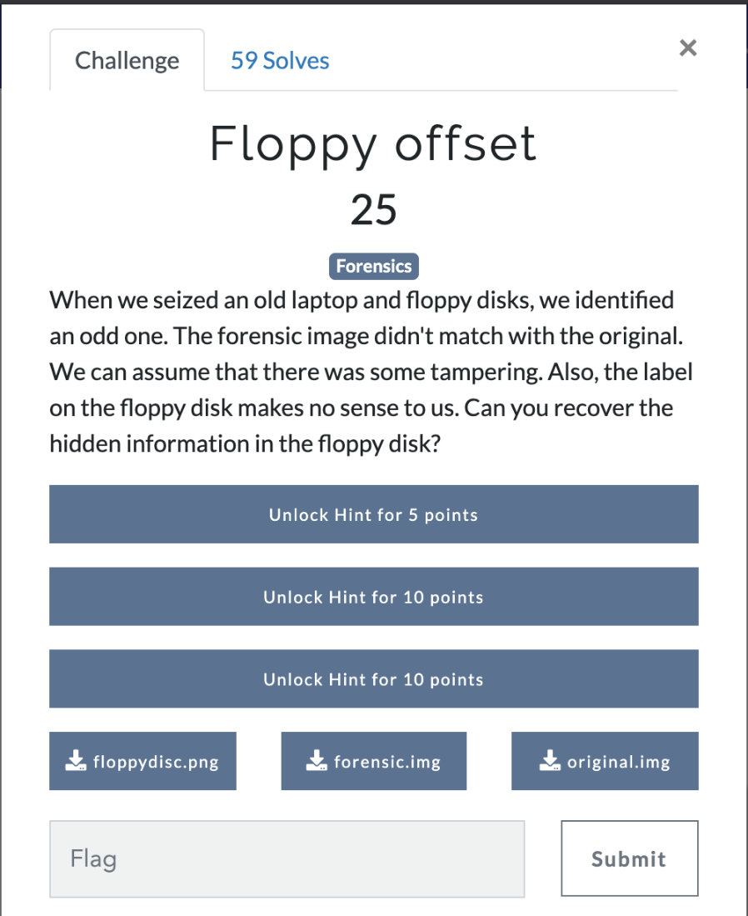
Answer: We are given 3 items, two .img files and a png. Below is the png.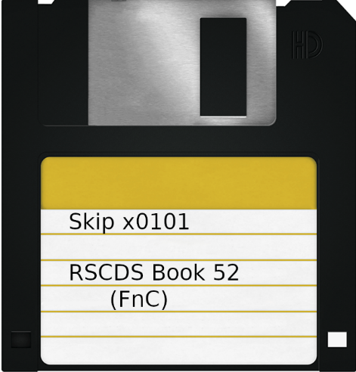

Using Binwalk let’s examine the .img files
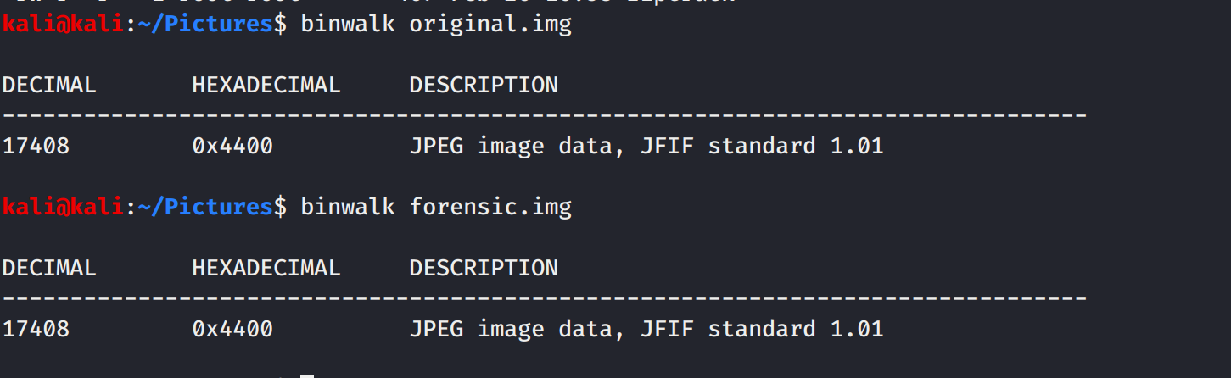
Looks like they both have an image, let’s extract and open it up.
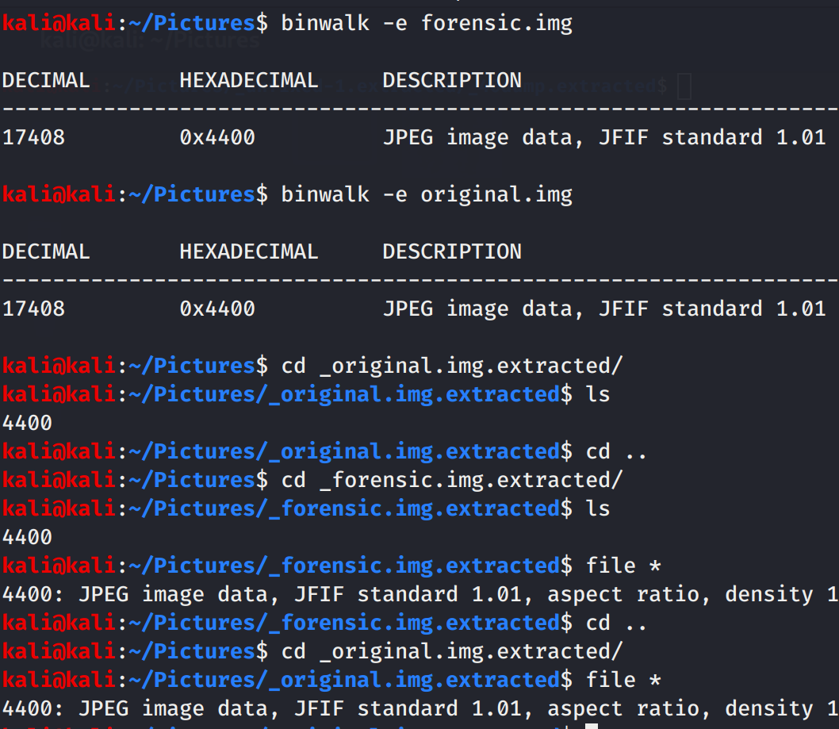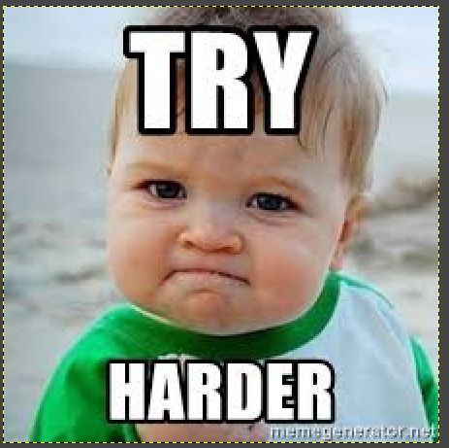
So the jpeg is just a meme. Let’s look deeper at the top files. Let grab the hex dump for each and compare.
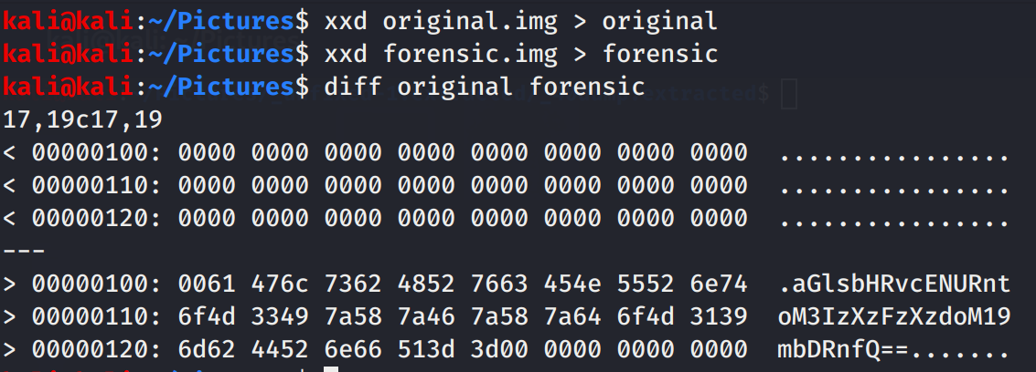
That looks like a base64 string. Converting it gives us, Flag: hilltopCTF{h3r3_1s_7h3_fl4g}

